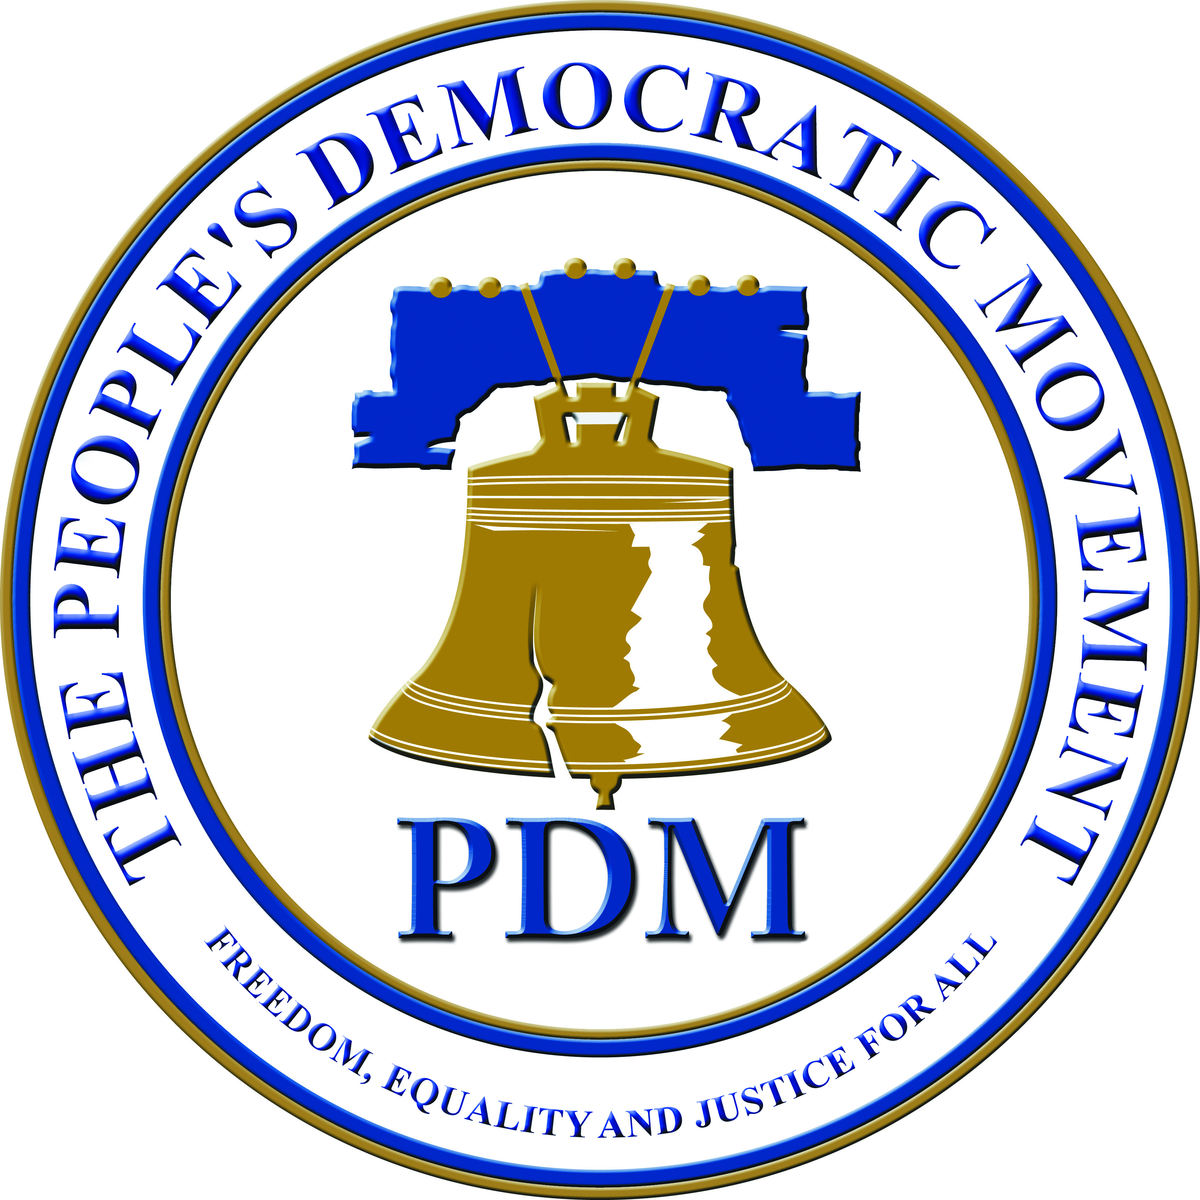

For Immediate Release:

25th January 2016

The Peoples Democratic Movement in preparation for the upcoming General Election is hereby notifying the voting public that it is opening its process for candidate selection.

The Party’s Constitution makes provision for the selection of candidates and qualifications for elected office in section 24 but namely:

- Be members of the Party in good standing
- Be registered voters and
- Satisfy the qualifications for membership of the Legislature as laid down by the Constitution of the Turks and Caicos Islands.

Additionally, prospective candidates for elections shall be either:

- Recommended to the Candidates Committee in writing by the Branch of the Party in the constituency concerned;
- Recommended to the Candidates Committee by an affiliated member of the Party or
- An individual member of the Party in good standing who applies in writing to the Candidates Committee.

The Peoples Democratic Movement throughout the Islands are readying themselves in preparation to bring a better government to the Turks and Caicos people and usher in a new era of PDM Government.

Prospective candidates are required to join an Island Branch in their respective constituencies.

