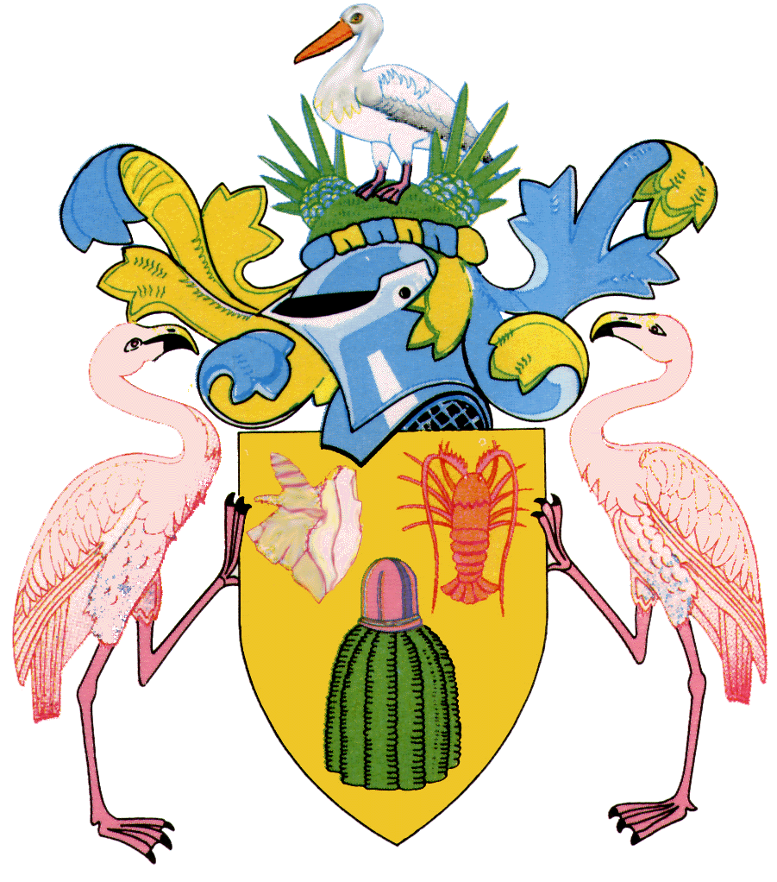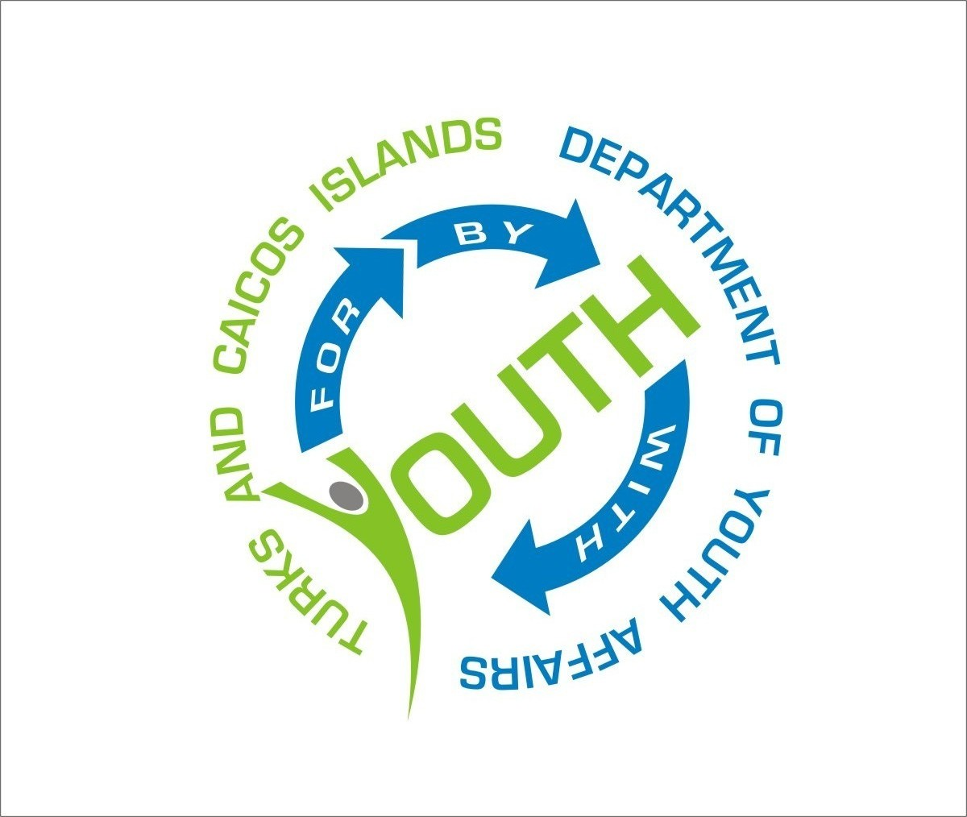DEPARTMENT OF YOUTH AFFAIRS
Ministry of Education, Youth, Sports & Library Services
Turks & Caicos Islands, British West Indies

December 9, 2014

PRESS RELEASE

TCI NATIONAL YOUTH AMBASSADOR, DONTE FRANCIS GIVE REMARKS AT ANTI-CORRUPTION DAY 2014

“Permit me to adopt the already established protocol, ladies and gentlemen, good morning. This is a very important day for every Turks and Caicos Islander. I notice that this is the first commemoration of the National Anti-Corruption Day and we should be very proud of this. It is no secret that corruption lies among us within these “Beautiful By Nature” Turks and Caicos Islands.

“Today gives us the opportunity to reflect on a serious issue- that of corruption. Today marks an opportunity for us to proclaim our motivation and perseverance to battle corruption.

“There is no society, which exists that does not have to deal with corruption. Research tells us that corruption exists in all societies, be it Government, civil society organisations or private sector businesses. Indeed, this is something we face globally. Therefore in addressing corruption, let us stand tall and develop a worldwide concept.

“When one thinks of corruption, what comes to mind- something contrary to the law, right? You would be surprised how many of us in our daily lives perform some act of corruption. From giving someone a ‘little’ cash to hasten an application form; paying to not do a driver’s test; manipulating prices when you know the items are not supposed to be that high to ‘blinding’ an eye to someone changing accounting figures- these are all acts of corruption which we sometimes say is the way of life. Yes ladies and gentlemen, this is what it is these days. We believe that because some things have been going on for years, that bad as we know them to be, we still justify doing them by saying ‘everyone is doing the same’. We must stop this kind of thinking. We must call these incidents as we see them-acts of corruption that must be eliminated in our society.

“We must understand that corruption affects our social and economic growth and development. Do we want this to become a monetary Ebola?

“We need not forget that the youth of our country is our gateway to a brighter Turks and Caicos. Pushing our youth in accumulating the knowledge of ethical behavior, eradicating corruption and their right to education are all key things we so need to do to ensure that the key to locking away our future generations of citizens from witnessing a corruption-free Turks and Caicos be locked away.

“Therefore, we need to report corruption, create an environment where the laws succeed and strive for integrity: The bedrock for prosperity and posterity. I would also like to echo the words of the song lyrics sang by the students of the Newman’s Preparatory Primary School “Integrity’s the only way, I take responsibility for everything I do and say, Integrity is the real deal.”

“May we as Turks and Caicos Islanders and residents of this country join me in repeating a pledge from this day forward? Please repeat after me placing your right hand on your heart “I will say NO to corruption, I will say NO to a bribe, I will say NO to corruption, I will not forget my Integrity pride”.

“Thank you for your attention,
“May God bless our nation and bless us all. Amen!”

Donte Francis
National Youth Ambassador
