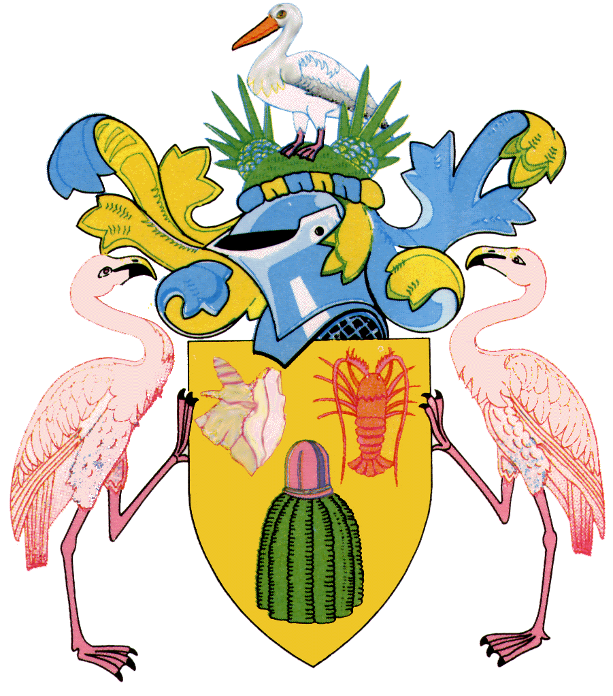

Ministry of Home Affairs, Transportation & Communication
DEPARTMENT OF SOCIAL DEVELOPMENT & GENDER AFFAIRS

November 18, 2015

Universal Children’s Day Press Release
The Department of Social Development and Gender Affairs/ Ministry of Home Affairs, Transportation and Communication will join the rest of the world on the 20th November 20, in celebration of ‘Universal Children’s Day’ also recognized as World Day of Prayer and Action for Children (WDPAC).
Universal Children’s Day was first established by the United Nations (UN) in 1954 in an effort to promote the welfare of children everywhere and to encourage understanding between children all over the world. The day also celebrates when the Declaration of the Rights of the Child was adopted in 1959 and the Convention of the Rights of the Child in 1989.
The theme “Stop Violence against Children” is a recurrent one that has been used by UNICEF since 2011. Universal Children’s Day is not simply just a day to celebrate children for who they are, but to bring about awareness to communities and children around the world that have succumbed to violence in forms of abuse, exploitation and discrimination. Violence against children takes many forms, including domestic violence, sexual assault/abuse, physical and emotional abuse, child trafficking, child labour, and harsh disciplinary practices. Such violence can inflict both physical and psychological harm and damage to children.
Violence against children can be prevented. The World Day of Prayer and Action for Children highlights three proven child protection strategies:
  - Protecting children through universal birth registration
  - Promoting positive parenting and Nonviolent discipline
  - Ending child marriages
As the primary agency responsible for Child Care and Protection the Department of Social Development and Gender Affairs joins UNICEF in its fight to shine a much stronger light on the millions of children in every country and at every level of society who are victims of violence and abuse that continue to go unnoticed and under-reported.
The World Day of Prayer and Action for Children is an opportunity for all sectors of society ‐ governments, intergovernmental organizations, non‐governmental organizations and religious groups ‐ to work together to end violence against children.

The rainbow of the logo symbolizes the diversity of the human family and the universal hope that all children will one day grow to their full potential in a peaceful world. The child painting the rainbow represents the inspired work of people of goodwill everywhere.

The Department will be hosting activities in observance of this day:

- Educational Sessions throughout the various communities for Parents/ Guardians on Promoting Positive Parenting and nonviolent discipline. Awareness sessions will be also be conducted with the PTA groups as well.

- Morning Devotions will be held in the schools on Friday 20 November where Religious Leaders will conduct Devotions along with Social Workers. Children will wear the colors of the rainbow to signify the UCD Logo.

- “National Day of Prayer” by Sister Peggy on Heart to Heart Inspiration via Radio Turks and Caicos 20 November

- Churches will incorporate the theme into their services and prayer groups

- “Good Deeds Day” – where staff will visit the SNAP Centre in Providenciales and provide support and assistance where needed to the children

- Public Education series –“Pass it on” where staff will distribute pamphlets, brochures, bookmarks on the theme Stop Violence against children at IGA Supermarket, Hospitals, Airport and Downtown Providenciales

- “The Wall of Caring” – children from various schools will color in the work pages of the “Know Your Rights Children’s Book” and the coloring art work will be plastered on the clear walls of the Department in Providenciales.

Do your part and “Stop Violence against Children” within the TCI and the world at large. In recognition of this day, the entire communities of the TCI is asked to wear the colors of the rainbow, that signifies diversity of the human family and the universal hope that all children will one day grow to their full potential in a peaceful world.

